U01E07 – Php Scripts – Functions
Make the following scripts using php.
Create yout own Functions and include it in your script
Funcions: https://www.w3schools.com/php/php_functions.asp
Include external scripts (in different files) in your script:
https://www.w3schools.com/php/php_includes.asp

- Create a script named functionsArrays.php that contains a series of functions to be executed with one-dimensional arrays and integers:
searchMinimumValue: returns the minimum value of an array. Parameters: array.
searchMaxValue: the same but the maximum value.
mediaArray: returns the average of the array. Parameter: array.
isInArray: tells us whether or not a number is in the array and in what position.
Parameter: array, value Return: position or -1 (if not exits).
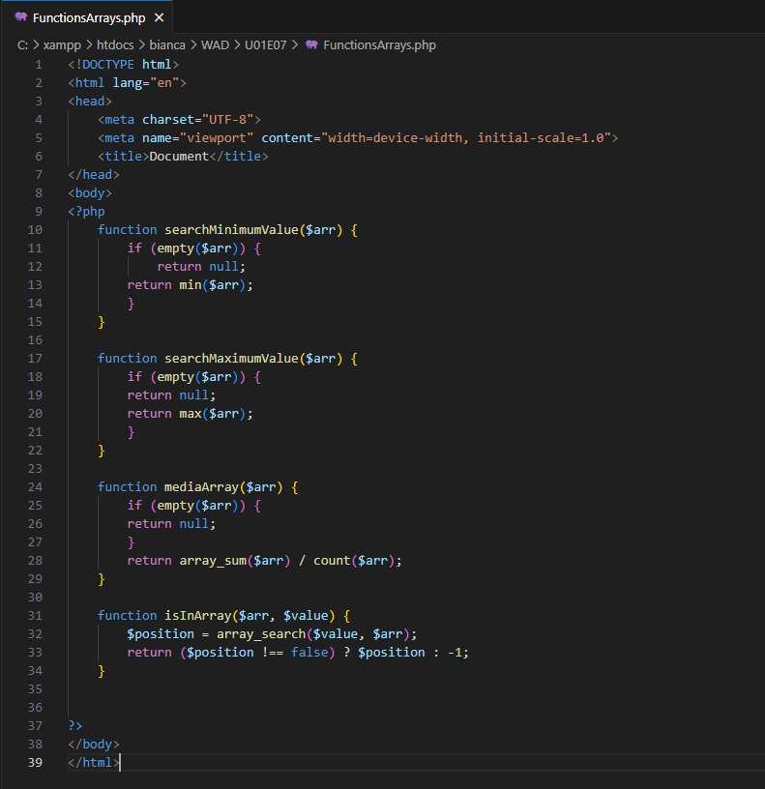

- Create a script (function library) for (two-dimensional) arrays of integers that contains the following functions:
searchFilaArrayBi: returns row “x” of the array that is passed as a parameter.
searchColumnaArrayBi: returns the column “y” of the array that is passed as a parameter.
positionArrayBi: Returns the row and column of the first time a certain element appears within the two-dimensional array. When the number does not exist in the array, the function returns the array {-1, -1}.
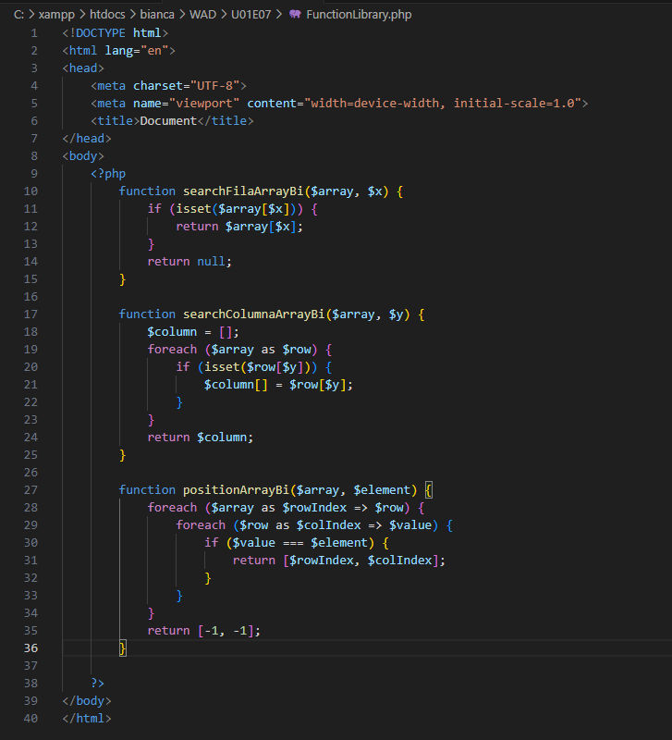
Create a main script from which you include the function files created above and declare an array of numbers and a bidimensional array of numbers and show:
-Calculate the maximun and the minimun of bidimensional array an show the number in the bidimensional array between the max and the min.
-Calculate the average of each row of the bidimensional array and then calculate the average of the rows.
-For each number of the normal array say how many times it appears in the bidimensional array. Create an array of results saying number an how many times.

